Lesson 5: CNN
@P S Vishnu

Normalizing image inputs
This standardization makes our model train and reach a minimum error, faster!
Data normalization is typically done by subtracting the mean (the average of all pixel values) from each pixel, and then dividing the result by the standard deviation of all the pixel values.

MLP Structure
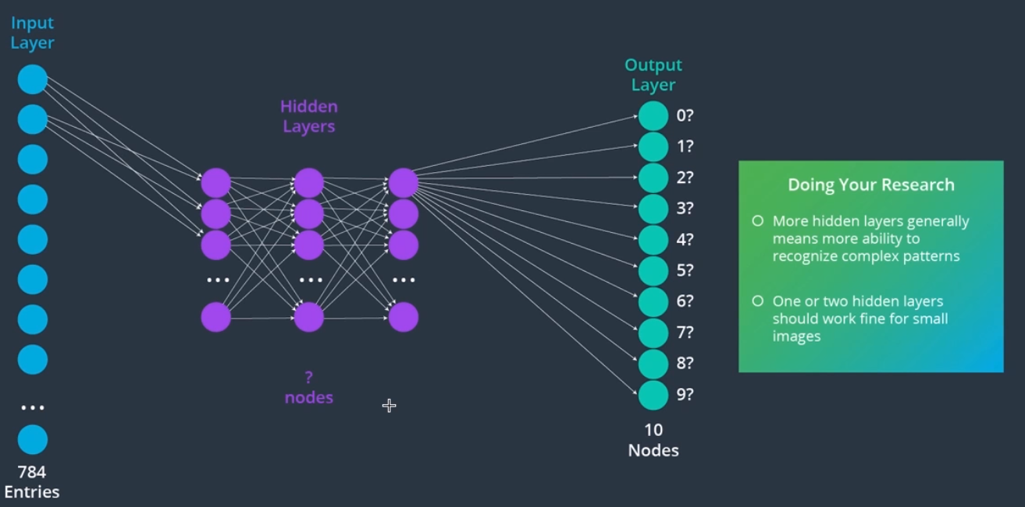

Class scores
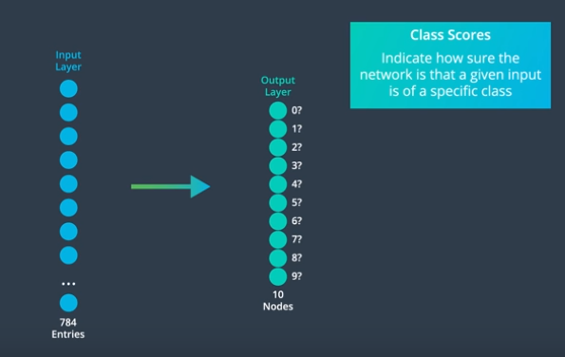

Loss & optimization
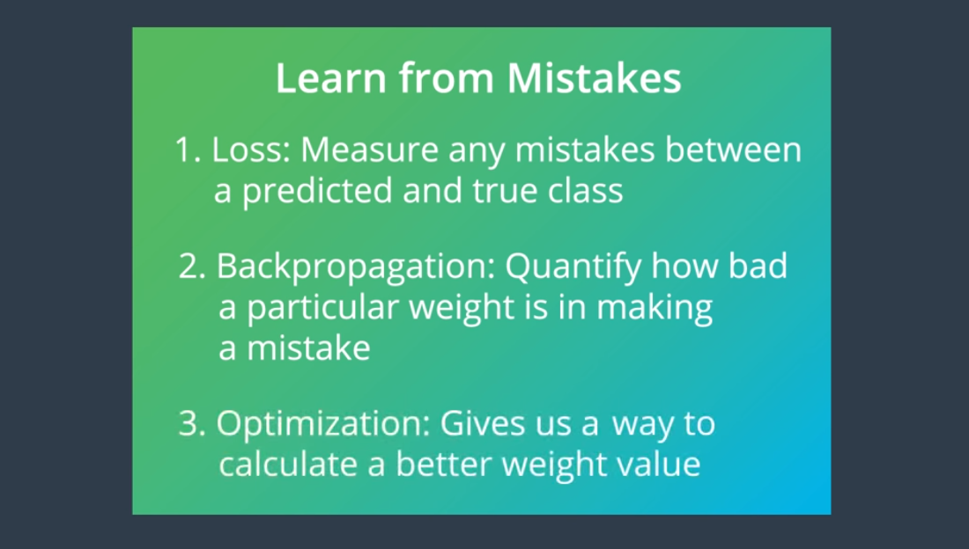

- Common example of optimization function is gradient descent. Purpose of loss function, minimizing the loss and finding the best weights.
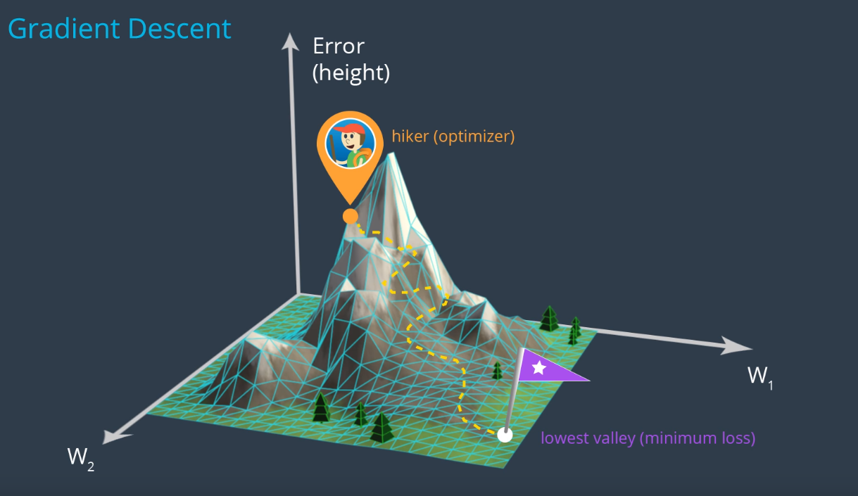

Evolution of Gradient descent: https://www.youtube.com/watch?v=nhqo0u1a6fw
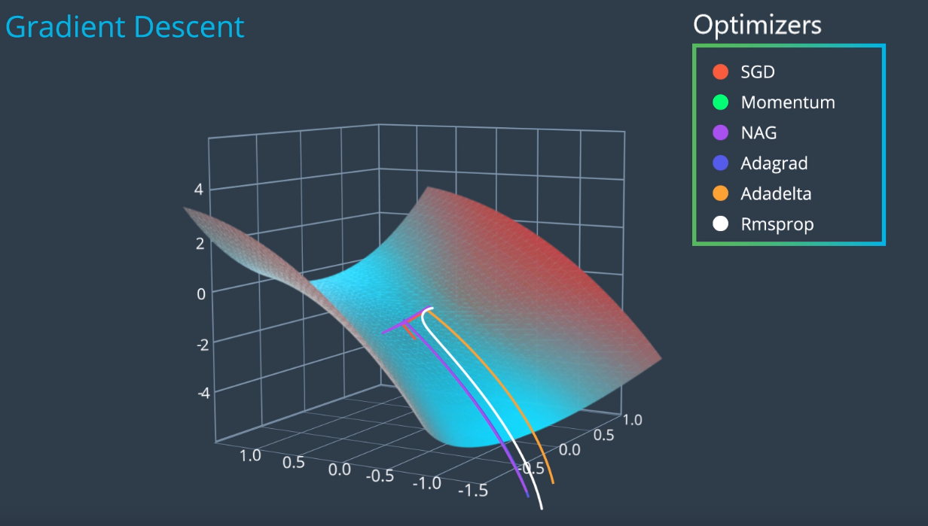

- Categorical cross entropy loss is used as our log function for our MNIST classification problem.
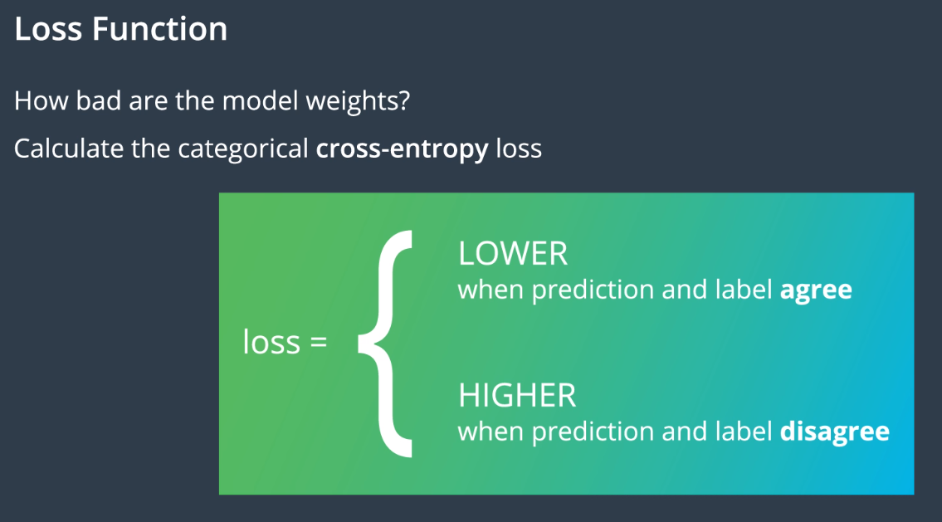

Rectified Linear Unit (ReLu) Activation function
The purpose of an activation function is to scale the outputs of a layer so that they are a consistent, small value(for efficiency). .
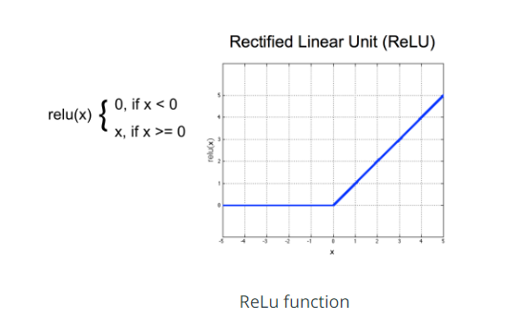

Convolutional Layers in PyTorch

There is a two part process -
- To defining a convolutional layer and
- Defining the feed-forward behavior of a model (how an input moves through the layers of a network.

